

Practical No.: 7
Aim –
Perform DOM traversal and updates; develop a To-Do List application with add, edit, and delete features. Implement a registration form using JavaScript event handling and form validation.
Software/Tools Required –
VSCode, Chrome, HTML5, CSS3, Javascript (ES6)
Experiment Program Code –
index.html

<!DOCTYPE html>
<html lang="en">
<head>
<meta charset="UTF-8">
<meta name="viewport" content="width=device-width, initial-scale=1.0">
<title>My To-Do List</title>
<link rel="preconnect" href="https://fonts.googleapis.com">
<link rel="preconnect" href="https://fonts.gstatic.com" crossorigin>
<link href="https://fonts.googleapis.com/css2?family=Poppins:wght@400;500;600;700&family=Inter:wght@400;500;600&display=swap" rel="stylesheet">

<style>
:root{
--teal-1:#0d9488;
--teal-2:#0891b2;
--ink:#0f2d33;
--muted:#5b7580;
--card:#ffffff;
--field:#f0f6f6;
--edit-1:#f59e0b;
--edit-2:#f97316;
--del-1:#f43f5e;
--del-2:#e11d48;
--border:#e3edee;
}

*{ box-sizing: border-box; }

body{
margin: 0;
min-height: 100vh;
font-family: 'Inter', -apple-system, BlinkMacSystemFont, sans-serif;
background: linear-gradient(160deg, #f4fbfb 0%, #eaf6f6 45%, #e3f1f5 100%);
display: flex;
align-items: center;
justify-content: center;
padding: 40px 16px;
position: relative;
overflow: hidden;
}

.bg-scene{
position: fixed;
inset: 0;
z-index: 0;
pointer-events: none;
overflow: hidden;
}

.blob{
position: absolute;
border-radius: 50%;
filter: blur(70px);
opacity: 0.55;
animation-iteration-count: infinite;
animation-timing-function: ease-in-out;
}
.blob-1{
width: 380px; height: 380px;
top: -100px; left: -90px;
background: radial-gradient(circle, rgba(13,148,136,0.55), transparent 70%);
animation-name: drift1;
animation-duration: 22s;
}
.blob-2{
width: 420px; height: 420px;
bottom: -140px; right: -110px;
background: radial-gradient(circle, rgba(8,145,178,0.5), transparent 70%);
animation-name: drift2;
animation-duration: 26s;
}
.blob-3{
width: 300px; height: 300px;
top: 40%; left: 60%;
background: radial-gradient(circle, rgba(45,212,191,0.45), transparent 70%);
animation-name: drift3;
animation-duration: 19s;
}
.blob-4{
width: 260px; height: 260px;
top: 12%; left: 20%;
background: radial-gradient(circle, rgba(94,234,212,0.4), transparent 70%);
animation-name: drift4;
animation-duration: 24s;
}

@keyframes drift1{
0%,100%{ transform: translate(0,0) scale(1); }
33%{ transform: translate(60px,40px) scale(1.12); }
66%{ transform: translate(20px,90px) scale(0.94); }
}
@keyframes drift2{
0%,100%{ transform: translate(0,0) scale(1); }
33%{ transform: translate(-50px,-60px) scale(1.1); }
66%{ transform: translate(-90px,-10px) scale(0.95); }
}
@keyframes drift3{
0%,100%{ transform: translate(0,0) scale(1); }
50%{ transform: translate(-70px,50px) scale(1.15); }
}
@keyframes drift4{
0%,100%{ transform: translate(0,0) scale(1); }
50%{ transform: translate(50px,-40px) scale(0.9); }
}

.grid-overlay{
position:absolute;
inset:0;
background-image:
linear-gradient(rgba(15,61,63,0.035) 1px, transparent 1px),
linear-gradient(90deg, rgba(15,61,63,0.035) 1px, transparent 1px);
background-size: 46px 46px;
mask-image: radial-gradient(circle at 50% 40%, black 0%, transparent 75%);
}

.particle{
position:absolute;
bottom:-20px;
border-radius: 50%;
background: radial-gradient(circle, rgba(13,148,136,0.65), rgba(8,145,178,0.15));
animation-name: rise;
animation-timing-function: linear;
animation-iteration-count: infinite;
}
@keyframes rise{
0%{ transform: translateY(0) translateX(0); opacity: 0; }
8%{ opacity: 0.8; }
90%{ opacity: 0.4; }
100%{ transform: translateY(-112vh) translateX(var(--drift, 40px)); opacity: 0; }
}

.tilt-wrap{
perspective: 1400px;
position: relative;
z-index: 1;
}

.container{
width: 100%;
max-width: 440px;
background: var(--card);
border-radius: 28px;
padding: 36px 32px 26px;
box-shadow:
0 30px 60px -20px rgba(6, 60, 60, 0.25),
0 8px 20px -8px rgba(6, 60, 60, 0.12);
position: relative;
overflow: hidden;
transform-style: preserve-3d;
transform: perspective(1400px) rotateX(0deg) rotateY(0deg);
transition: transform 0.5s cubic-bezier(0.22, 1, 0.36, 1), box-shadow 0.4s ease;
will-change: transform;
}

.container.tilting{
transition: transform 0.08s linear;
}

.container::before{
content:"";
position:absolute;
top:-70px; right:-70px;
width:180px; height:180px;
background: linear-gradient(135deg, var(--teal-1), var(--teal-2));
opacity:0.10;
border-radius:50%;
}

.glare{
position:absolute;
inset:0;
pointer-events:none;
background: radial-gradient(circle at 50% 30%, rgba(255,255,255,0.55), transparent 55%);
opacity: 0;
transition: opacity 0.4s ease;
mix-blend-mode: overlay;
}
.container.tilting .glare{ opacity: 1; }

.depth-1{ transform: translateZ(26px); }
.depth-2{ transform: translateZ(16px); }
.depth-3{ transform: translateZ(8px); }

.icon-badge{
width: 56px;
height: 56px;
margin: 0 auto 16px;
border-radius: 16px;
background: linear-gradient(135deg, var(--teal-1), var(--teal-2));
display:flex;
align-items:center;
justify-content:center;
box-shadow: 0 10px 20px -8px rgba(13,148,136,0.55);
}
.icon-badge svg{ width:26px; height:26px; }

h1{
font-family:'Poppins', sans-serif;
text-align:center;
font-size: 1.6rem;
font-weight: 700;
color: var(--ink);
margin: 0 0 4px;
letter-spacing: -0.01em;
}

.subtitle{
text-align:center;
color: var(--muted);
font-size: 0.86rem;
margin: 0 0 26px;
}

.input-row{
display:flex;
gap: 10px;
margin-bottom: 26px;
}

#taskInput{
flex:1;
border: 1.5px solid var(--border);
background: var(--field);
border-radius: 14px;
padding: 13px 16px;
font-size: 0.95rem;
font-family: inherit;
color: var(--ink);
outline: none;
transition: border-color 0.18s ease, box-shadow 0.18s ease;
}
#taskInput::placeholder{ color: #93a9ae; }
#taskInput:focus{
border-color: var(--teal-2);
box-shadow: 0 0 0 4px rgba(8,145,178,0.14);
}

#addBtn{
border: none;
padding: 0 22px;
border-radius: 14px;
background: linear-gradient(135deg, var(--teal-1), var(--teal-2));
color: white;
font-weight: 600;
font-size: 0.92rem;
cursor: pointer;
transition: transform 0.15s ease, box-shadow 0.15s ease;
box-shadow: 0 8px 16px -6px rgba(8,145,178,0.55);
}
#addBtn:hover{ transform: translateY(-1px); }
#addBtn:active{ transform: translateY(0); }

.list-header{
display:flex;
align-items:center;
justify-content: space-between;
margin-bottom: 14px;
}
.list-header h2{
font-family:'Poppins', sans-serif;
font-size: 1.02rem;
font-weight: 600;
color: var(--ink);
margin: 0;
}
.count-chip{
background: #e7f6f4;
color: var(--teal-1);
font-size: 0.76rem;
font-weight: 600;
padding: 5px 12px;
border-radius: 999px;
}

ul{
list-style:none;
margin: 0;
padding: 0;
display:flex;
flex-direction: column;
gap: 10px;
min-height: 40px;
}

li{
display:flex;
align-items:center;
justify-content: space-between;
gap: 10px;
background: var(--field);
border: 1px solid var(--border);
padding: 13px 16px;
border-radius: 16px;
animation: pop 0.22s ease;
}
li.done span{ text-decoration: line-through; color:#9fb1b5; }

@keyframes pop{
from{ opacity:0; transform: translateY(6px) scale(0.98); }
to{ opacity:1; transform: translateY(0) scale(1); }
}

li span{
font-size: 0.92rem;
color: var(--ink);
word-break: break-word;
flex: 1;
cursor: pointer;
}

.buttons{
display:flex;
gap: 6px;
flex-shrink: 0;
}

.buttons button{
border:none;
padding: 7px 14px;
border-radius: 999px;
font-size: 0.78rem;
font-weight: 600;
color: white;
cursor: pointer;
transition: filter 0.15s ease, transform 0.15s ease;
}
.buttons button:hover{ filter: brightness(1.06); transform: translateY(-1px); }

.edit{ background: linear-gradient(135deg, var(--edit-1), var(--edit-2)); }
.delete{ background: linear-gradient(135deg, var(--del-1), var(--del-2)); }

.empty-state{
text-align:center;
color: var(--muted);
font-size: 0.85rem;
padding: 22px 0 8px;
}

footer{
margin-top: 26px;
padding-top: 16px;
border-top: 1px solid var(--border);
text-align:center;
color: #9fb1b5;
font-size: 0.75rem;
line-height: 1.6;
}
footer b{ color: var(--teal-2); }
</style>
</head>
<body>

<div class="bg-scene" id="bgScene">
<div class="blob blob-1"></div>
<div class="blob blob-2"></div>
<div class="blob blob-3"></div>
<div class="blob blob-4"></div>
<div class="grid-overlay"></div>
</div>

<div class="tilt-wrap">
<div class="container" id="tiltCard">
<div class="glare"></div>

<div class="icon-badge depth-1">
<svg viewBox="0 0 24 24" fill="none" stroke="white" stroke-width="2.6" stroke-linecap="round" stroke-linejoin="round">
<polyline points="20 6 9 17 4 12"></polyline>
</svg>
</div>

<h1 class="depth-2">My To-Do List</h1>
<p class="subtitle depth-3">Little tasks. Big progress.</p>

<div class="input-row depth-2">
<input type="text" id="taskInput" placeholder="What would you like to do?">
<button id="addBtn">+ Add</button>
</div>

<div class="list-header depth-3">
<h2>Today's Tasks</h2>
<span class="count-chip" id="countChip">0 tasks</span>
</div>

<ul id="taskList"></ul>
<p class="empty-state" id="emptyState">No tasks yet — add your first one above ✨</p>

<footer>Designed by <b>Salim Ansari</b><br>PRN: <b>24070521005</b></footer>
</div>
</div>

<script>
const taskInput = document.getElementById('taskInput');
const addBtn = document.getElementById('addBtn');
const taskList = document.getElementById('taskList');
const emptyState = document.getElementById('emptyState');
const countChip = document.getElementById('countChip');

function updateMeta(){
const total = taskList.children.length;
countChip.textContent = total === 1 ? "1 task" : total + " tasks";
emptyState.style.display = total === 0 ? "block" : "none";
}

function addTask(){
const task = taskInput.value.trim();
if (task === ""){
taskInput.style.borderColor = "#f43f5e";
taskInput.placeholder = "Please enter a task!";
setTimeout(() => { taskInput.style.borderColor = ""; taskInput.placeholder = "What would you like to do?"; }, 1400);
return;
}

const li = document.createElement('li');

const span = document.createElement('span');
span.textContent = task;
span.title = "Click to mark as done";
span.addEventListener('click', () => li.classList.toggle('done'));

const buttons = document.createElement('div');
buttons.className = 'buttons';

const editBtn = document.createElement('button');
editBtn.textContent = 'Edit';
editBtn.className = 'edit';
editBtn.addEventListener('click', (e) => {
e.stopPropagation();
const newTask = prompt("Edit your task:", span.textContent);
if (newTask !== null && newTask.trim() !== "") {
span.textContent = newTask.trim();
}
});

const deleteBtn = document.createElement('button');
deleteBtn.textContent = 'Delete';
deleteBtn.className = 'delete';
deleteBtn.addEventListener('click', (e) => {
e.stopPropagation();
li.remove();
updateMeta();
});

buttons.appendChild(editBtn);
buttons.appendChild(deleteBtn);
li.appendChild(span);
li.appendChild(buttons);
taskList.appendChild(li);

taskInput.value = "";
taskInput.focus();
updateMeta();
}

addBtn.addEventListener('click', addTask);
taskInput.addEventListener('keydown', (e) => {
if (e.key === "Enter") addTask();
});

updateMeta();

const tiltCard = document.getElementById('tiltCard');
const MAX_TILT = 9;
const MAX_LIFT = 1.015;

function handleTiltMove(e){
const rect = tiltCard.getBoundingClientRect();
const x = e.clientX - rect.left;
const y = e.clientY - rect.top;

const percentX = (x / rect.width - 0.5) * 2;
const percentY = (y / rect.height - 0.5) * 2;

const rotateY = percentX * MAX_TILT;
const rotateX = percentY * -MAX_TILT;

tiltCard.classList.add('tilting');
tiltCard.style.transform =
`perspective(1400px) rotateX(${rotateX}deg) rotateY(${rotateY}deg) scale3d(${MAX_LIFT}, ${MAX_LIFT}, ${MAX_LIFT})`;

const glare = tiltCard.querySelector('.glare');
glare.style.background =
`radial-gradient(circle at ${x}px ${y}px, rgba(255,255,255,0.5), transparent 55%)`;
}

function resetTilt(){
tiltCard.classList.remove('tilting');
tiltCard.style.transform = 'perspective(1400px) rotateX(0deg) rotateY(0deg) scale3d(1, 1, 1)';
}

tiltCard.addEventListener('mousemove', handleTiltMove);
tiltCard.addEventListener('mouseleave', resetTilt);

tiltCard.addEventListener('touchmove', (e) => {
const touch = e.touches[0];
handleTiltMove({ clientX: touch.clientX, clientY: touch.clientY });
}, { passive: true });
tiltCard.addEventListener('touchend', resetTilt);

const bgScene = document.getElementById('bgScene');
const PARTICLE_COUNT = 22;

for (let i = 0; i < PARTICLE_COUNT; i++){
const p = document.createElement('div');
p.className = 'particle';

const size = 4 + Math.random() * 7;
const left = Math.random() * 100;
const duration = 14 + Math.random() * 16;
const delay = Math.random() * -30;
const drift = (Math.random() * 120 - 60) + 'px';

p.style.width = size + 'px';
p.style.height = size + 'px';
p.style.left = left + '%';
p.style.setProperty('--drift', drift);
p.style.animationDuration = duration + 's';
p.style.animationDelay = delay + 's';

bgScene.appendChild(p);
}
</script>
</body>
</html>

Output –
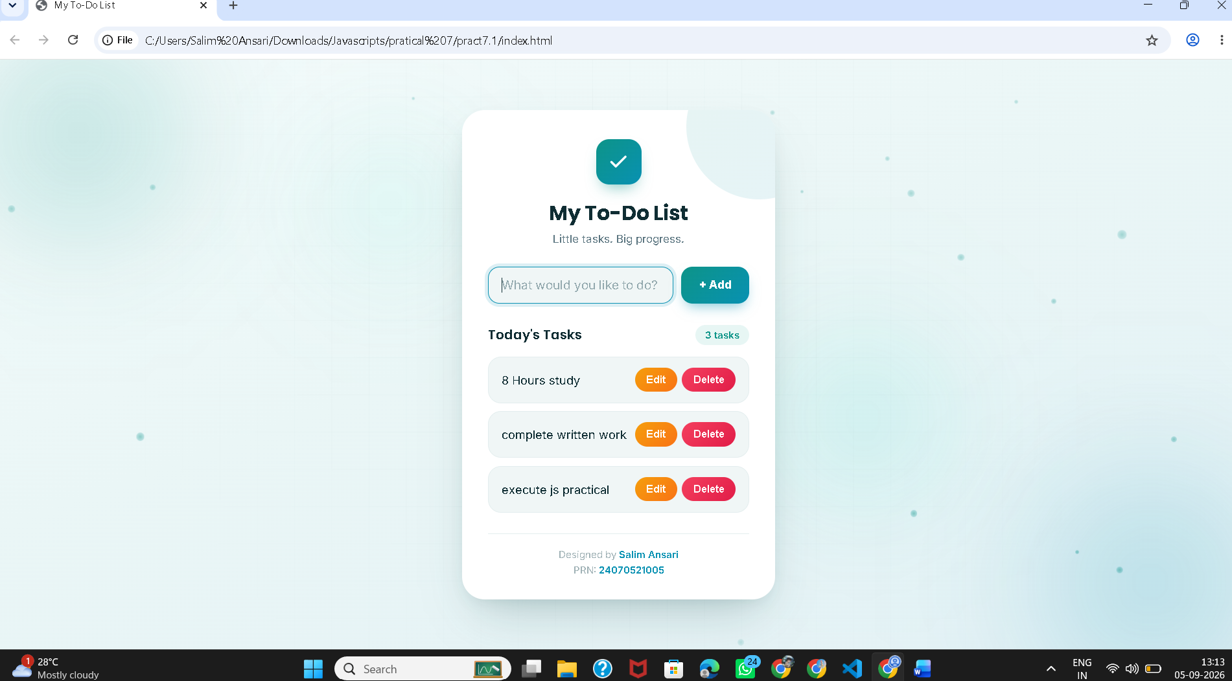

Case Study Title –
Implement a registration form using JavaScript event handling and form validation.
Case Study Program Code –
index.html

<!DOCTYPE html>
<html lang="en">
<head>
<meta charset="UTF-8">
<meta name="viewport" content="width=device-width, initial-scale=1.0">
<title>Create Account</title>
<link rel="preconnect" href="https://fonts.googleapis.com">
<link href="https://fonts.googleapis.com/css2?family=Space+Grotesk:wght@500;600;700&family=Inter:wght@400;500;600&display=swap" rel="stylesheet">
<link rel="stylesheet" href="style.css">
</head>
<body>

<div class="auth-card">

<aside class="panel-left">
<div class="mark">to-do</div>
<h2>Grow something<br>new today.</h2>
<p>Set up your account and start building.</p>

<svg class="art" viewBox="0 0 320 260" xmlns="http://www.w3.org/2000/svg">
<circle cx="160" cy="130" r="95" fill="rgba(255,255,255,0.06)"/>
<path d="M60 190 Q160 60 260 190" stroke="#E7B75F" stroke-width="3" fill="none" stroke-linecap="round"/>
<circle cx="60" cy="190" r="8" fill="#E7B75F"/>
<circle cx="160" cy="80" r="8" fill="#8FD3B6"/>
<circle cx="260" cy="190" r="8" fill="#E7B75F"/>
<rect x="120" y="150" width="80" height="60" rx="8" fill="#8FD3B6" opacity="0.85"/>
<rect x="140" y="128" width="40" height="26" rx="4" fill="#E7B75F"/>
</svg>
</aside>

<section class="panel-right">

<header class="card-head">
<h1>Create account</h1>
<p class="sub">Fill in your information below</p>
</header>

<form id="regForm" novalidate>

<p class="section-label">Personal information</p>

<div class="field-row">
<div class="field">
<label for="firstname">First name <span class="req">*</span></label>
<div class="input-icon">
<svg viewBox="0 0 24 24"><path d="M12 12a4.5 4.5 0 1 0 0-9 4.5 4.5 0 0 0 0 9Zm0 2c-4 0-8 2-8 5v1h16v-1c0-3-4-5-8-5Z"/></svg>
<input type="text" id="firstname" name="firstname" placeholder="First name">
</div>
<span class="error" id="err-firstname"></span>
</div>

<div class="field">
<label for="lastname">Last name</label>
<div class="input-icon">
<svg viewBox="0 0 24 24"><path d="M12 12a4.5 4.5 0 1 0 0-9 4.5 4.5 0 0 0 0 9Zm0 2c-4 0-8 2-8 5v1h16v-1c0-3-4-5-8-5Z"/></svg>
<input type="text" id="lastname" name="lastname" placeholder="Last name">
</div>
</div>
</div>

<div class="field">
<label>Birthday</label>
<div class="birthday-row">
<select id="bday-day" name="day"><option value="">Day</option></select>
<select id="bday-month" name="month"><option value="">Month</option></select>
<select id="bday-year" name="year"><option value="">Year</option></select>
</div>
<span class="error" id="err-birthday"></span>
</div>

<p class="section-label">Account details</p>

<div class="field-row">
<div class="field">
<label for="username">Username <span class="req">*</span></label>
<div class="input-icon">
<svg viewBox="0 0 24 24"><path d="M12 2 2 7v6c0 5 4.2 8.5 10 9 5.8-.5 10-4 10-9V7l-10-5Z"/></svg>
<input type="text" id="username" name="username" placeholder="Username">
</div>
<span class="error" id="err-username"></span>
</div>

<div class="field">
<label for="email">E-mail</label>
<div class="input-icon">
<svg viewBox="0 0 24 24"><path d="M3 5h18v14H3V5Zm0 0 9 7 9-7"/></svg>
<input type="text" id="email" name="email" placeholder="name@email.com">
</div>
<span class="error" id="err-email"></span>
</div>
</div>

<div class="field">
<label for="website">Website</label>
<div class="input-icon">
<svg viewBox="0 0 24 24"><path d="M12 2a10 10 0 1 0 0 20 10 10 0 0 0 0-20Zm0 0c2.5 2.7 4 6.2 4 10s-1.5 7.3-4 10m0-20c-2.5 2.7-4 6.2-4 10s1.5 7.3 4 10M2.5 9h19M2.5 15h19"/></svg>
<input type="text" id="website" name="website" placeholder="https://example.com">
</div>
</div>

<div class="field-row">
<div class="field">
<label for="password">Password <span class="req">*</span></label>
<div class="input-icon">
<svg viewBox="0 0 24 24"><path d="M6 11V8a6 6 0 1 1 12 0v3M5 11h14v10H5V11Z"/></svg>
<input type="password" id="password" name="password" placeholder="Password">
</div>
<span class="error" id="err-password"></span>
</div>

<div class="field">
<label for="repassword">Re-password <span class="req">*</span></label>
<div class="input-icon">
<svg viewBox="0 0 24 24"><path d="M6 11V8a6 6 0 1 1 12 0v3M5 11h14v10H5V11Z"/></svg>
<input type="password" id="repassword" name="repassword" placeholder="Confirm password">
</div>
<span class="error" id="err-repassword"></span>
</div>
</div>

<div class="field checkbox-field">
<input type="checkbox" id="terms" name="terms">
<label for="terms">I agree to the terms &amp; conditions.</label>
<span class="error" id="err-terms"></span>
</div>

<button type="submit" id="submitBtn">Create account ✦</button>

<div id="formStatus" class="status" role="status" aria-live="polite"></div>

</form>

<div class="designer">

Designed by <strong>Slaim Ansari</strong> <span>•</span> PRN: 24070521005
</div>

</section>
</div>

<script src="script.js"></script>
</body>
</html>

Script.js

const form = document.getElementById("regForm");
const firstname = document.getElementById("firstname");
const lastname = document.getElementById("lastname");
const dayEl = document.getElementById("bday-day");
const monthEl = document.getElementById("bday-month");
const yearEl = document.getElementById("bday-year");
const username = document.getElementById("username");
const email = document.getElementById("email");
const website = document.getElementById("website");
const password = document.getElementById("password");
const repassword = document.getElementById("repassword");
const terms = document.getElementById("terms");
const submitBtn = document.getElementById("submitBtn");
const formStatus = document.getElementById("formStatus");

function populateDropdown(selectEl, start, end) {
for (let i = start; i <= end; i++) {
const option = document.createElement("option");
option.value = i;
option.textContent = i;
selectEl.appendChild(option);
}
}

populateDropdown(dayEl, 1, 31);

const months = ["January","February","March","April","May","June",
"July","August","September","October","November","December"];
months.forEach((m, idx) => {
const option = document.createElement("option");
option.value = idx + 1;
option.textContent = m;
monthEl.appendChild(option);
});

const currentYear = new Date().getFullYear();
populateDropdown(yearEl, currentYear - 100, currentYear);

function showError(inputEl, errorId, message) {
document.getElementById(errorId).textContent = message;
const target = inputEl.closest(".input-icon") || inputEl;
target.classList.add("invalid");
target.classList.remove("valid");
}

function clearError(inputEl, errorId) {
document.getElementById(errorId).textContent = "";
const target = inputEl.closest(".input-icon") || inputEl;
target.classList.remove("invalid");
target.classList.add("valid");
}

function isValidEmail(value) {
// simple, readable email pattern: text@text.text
const pattern = /^[^\s@]+@[^\s@]+\.[^\s@]+$/;
return pattern.test(value);
}

function validateFirstname() {
if (firstname.value.trim() === "") {
showError(firstname, "err-firstname", "Firstname is required.");
return false;
}
clearError(firstname, "err-firstname");
return true;
}

function validateUsername() {
if (username.value.trim() === "") {
showError(username, "err-username", "Username is required.");
return false;
}
clearError(username, "err-username");
return true;
}

function validateEmail() {

if (email.value.trim() !== "" && !isValidEmail(email.value.trim())) {
showError(email, "err-email", "Please enter a valid email address.");
return false;
}
clearError(email, "err-email");
return true;
}

function validatePassword() {
if (password.value.trim() === "") {
showError(password, "err-password", "Password is required.");
return false;
}
if (password.value.length < 6) {
showError(password, "err-password", "Password must be at least 6 characters.");
return false;
}
clearError(password, "err-password");
return true;
}

function validateRepassword() {
if (repassword.value.trim() === "") {
showError(repassword, "err-repassword", "Please re-enter your password.");
return false;
}
if (repassword.value !== password.value) {
showError(repassword, "err-repassword", "Passwords do not match.");
return false;
}
clearError(repassword, "err-repassword");
return true;
}

function validateBirthday() {
const errEl = document.getElementById("err-birthday");
if (dayEl.value && monthEl.value && yearEl.value) {
errEl.textContent = "";
return true;
}
// Birthday not marked mandatory with * in the layout, so only warn,
// don't block submission.
errEl.textContent = "";
return true;
}

function validateTerms() {
const errEl = document.getElementById("err-terms");
if (!terms.checked) {
errEl.textContent = "You must agree to the terms & conditions.";
return false;
}
errEl.textContent = "";
return true;
}

[firstname, lastname, username, email, website, password, repassword].forEach(field => {
field.addEventListener("focus", () => {
console.log(`Focused: ${field.id}`);
});
});

firstname.addEventListener("blur", validateFirstname);
username.addEventListener("blur", validateUsername);
email.addEventListener("blur", validateEmail);
password.addEventListener("blur", validatePassword);
repassword.addEventListener("blur", validateRepassword);

dayEl.addEventListener("change", validateBirthday);
monthEl.addEventListener("change", validateBirthday);
yearEl.addEventListener("change", validateBirthday);
terms.addEventListener("change", validateTerms);

repassword.addEventListener("input", validateRepassword);

form.addEventListener("submit", function (event) {
event.preventDefault(); // stop actual page reload for this demo

const isFirstnameOk = validateFirstname();
const isUsernameOk = validateUsername();
const isEmailOk = validateEmail();
const isPasswordOk = validatePassword();
const isRepasswordOk = validateRepassword();
const isBirthdayOk = validateBirthday();
const isTermsOk = validateTerms();

const allValid = isFirstnameOk && isUsernameOk && isEmailOk &&
isPasswordOk && isRepasswordOk && isBirthdayOk && isTermsOk;

if (allValid) {
formStatus.textContent = "Account created successfully for " + firstname.value + "!";
formStatus.className = "status success";

form.reset();
[firstname, lastname, username, email, website, password, repassword]
.forEach(f => f.classList.remove("valid", "invalid"));
} else {
formStatus.textContent = "Please fix the highlighted errors above.";
formStatus.className = "status fail";
}
});

Style.css
:root {
--forest: #1E3A2C;
--forest-deep: #16291F;
--gold: #E7B75F;
--mint: #8FD3B6;
--page: #EFEBE2;
--card: #FFFFFF;
--ink: #20241F;
--muted: #7C8279;
--line: #E1DDD1;
--error: #C2402C;
}

* {
box-sizing: border-box;
}

body {
margin: 0;
min-height: 100vh;
display: flex;
align-items: center;
justify-content: center;
background: var(--page);
font-family: "Inter", Arial, sans-serif;
color: var(--ink);
padding: 40px 16px;
}

.auth-card {
width: 100%;
max-width: 920px;
min-height: 620px;
display: grid;
grid-template-columns: 320px 1fr;
background: var(--card);
border-radius: 18px;
overflow: hidden;
box-shadow: 0 20px 50px rgba(30, 58, 44, 0.18);
}

.panel-left {
background: linear-gradient(160deg, var(--forest) 0%, var(--forest-deep) 100%);
color: #fff;
padding: 40px 34px;
display: flex;
flex-direction: column;
position: relative;
}

.mark {
width: 40px;
height: 40px;
border-radius: 10px;
background: var(--gold);
color: var(--forest-deep);
font-family: "Space Grotesk", sans-serif;
font-weight: 700;
font-size: 14px;
display: flex;
align-items: center;
justify-content: center;
margin-bottom: 40px;
}

.panel-left h2 {
font-family: "Space Grotesk", sans-serif;
font-weight: 600;
font-size: 28px;
line-height: 1.25;
margin: 0 0 12px;
}

.panel-left p {
font-size: 14px;
color: rgba(255, 255, 255, 0.7);
line-height: 1.6;
margin: 0;
max-width: 220px;
}

.art {
margin-top: auto;
width: 100%;
height: auto;
}

.panel-right {
padding: 44px 48px 36px;
overflow-y: auto;
}

.card-head h1 {
font-family: "Space Grotesk", sans-serif;
font-weight: 700;
font-size: 27px;
margin: 0 0 6px;
}

.sub {
color: var(--muted);
font-size: 14px;
margin: 0 0 26px;
}

.section-label {
font-size: 12px;
font-weight: 600;
color: var(--forest);
letter-spacing: 0.03em;
margin: 0 0 16px;
padding-bottom: 8px;
border-bottom: 1px solid var(--line);
}

.req {
color: var(--error);
font-weight: 600;
}

.field-row {
display: flex;
gap: 18px;
}

.field-row .field {
flex: 1;
}

.field {
margin-bottom: 18px;
display: flex;
flex-direction: column;
}

label {
font-size: 13px;
font-weight: 500;
color: var(--ink);
margin-bottom: 7px;
}

.input-icon {
display: flex;
align-items: center;
gap: 8px;
border: 1.5px solid var(--line);
border-radius: 10px;
padding: 0 12px;
background: #FBFAF7;
transition: border-color 0.15s ease, background 0.15s ease;
}

.input-icon svg {
width: 16px;
height: 16px;
flex: none;
fill: none;
stroke: var(--muted);
stroke-width: 1.7;
}

.input-icon:focus-within {
border-color: var(--forest);
background: #fff;
}

.input-icon:focus-within svg {
stroke: var(--forest);
}

input[type="text"],
input[type="password"] {
border: none;
outline: none;
background: transparent;
padding: 10px 0;
font-size: 14.5px;
font-family: "Inter", sans-serif;
color: var(--ink);
width: 100%;
}

input::placeholder {
color: #ADA898;
}

.input-icon.invalid {
border-color: var(--error);
}

.input-icon.valid {
border-color: var(--mint);
}

.birthday-row {
display: flex;
gap: 10px;
}

select {
flex: 1;
border: 1.5px solid var(--line);
border-radius: 10px;
padding: 10px 10px;
font-size: 14px;
font-family: "Inter", sans-serif;
color: var(--ink);
background: #FBFAF7;
}

select:focus {
border-color: var(--forest);
outline: none;
}

.checkbox-field {
flex-direction: row;
align-items: center;
gap: 10px;
margin-bottom: 24px;
flex-wrap: wrap;
}

.checkbox-field input[type="checkbox"] {
width: 17px;
height: 17px;
accent-color: var(--forest);
}

.checkbox-field label {
margin: 0;
font-size: 13.5px;
}

.checkbox-field .error {
width: 100%;
order: 3;
}

.error {
color: var(--error);
font-size: 12px;
min-height: 15px;
margin-top: 5px;
}

button {
width: 100%;
padding: 13px;
border: none;
border-radius: 10px;
background: var(--forest);
color: #fff;
font-family: "Inter", sans-serif;
font-size: 14.5px;
font-weight: 600;
cursor: pointer;
transition: background 0.15s ease;
}

button:hover {
background: var(--forest-deep);
}

.status {
margin-top: 16px;
font-size: 13.5px;
text-align: center;
min-height: 18px;
}

.status.success {
color: var(--forest);
}

.status.fail {
color: var(--error);
}

@media (max-width: 760px) {
.auth-card {
grid-template-columns: 1fr;
}
.panel-left {
display: none;
}
}

Output –
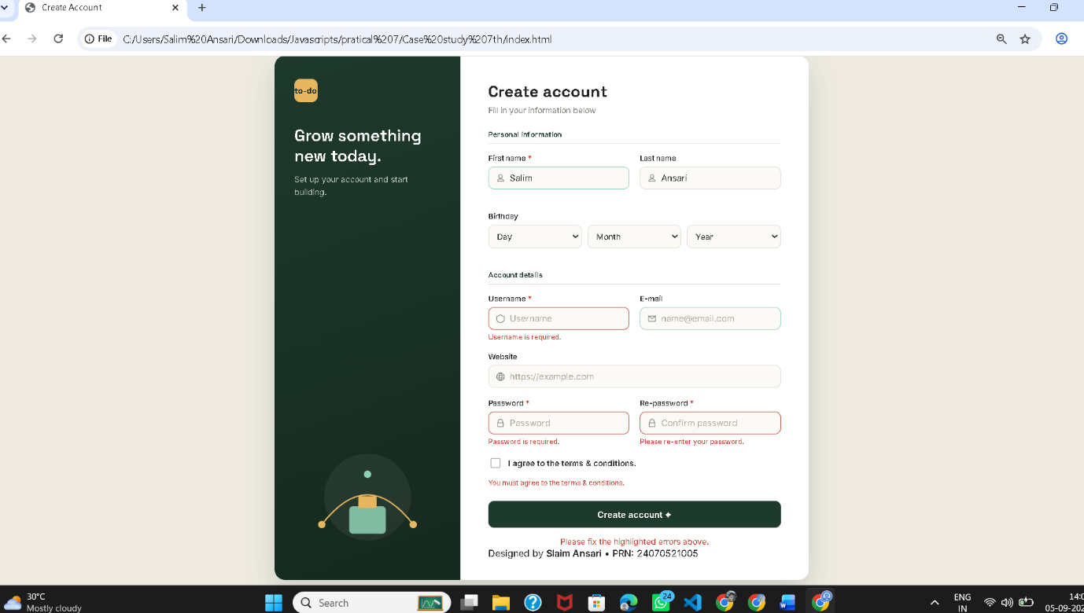

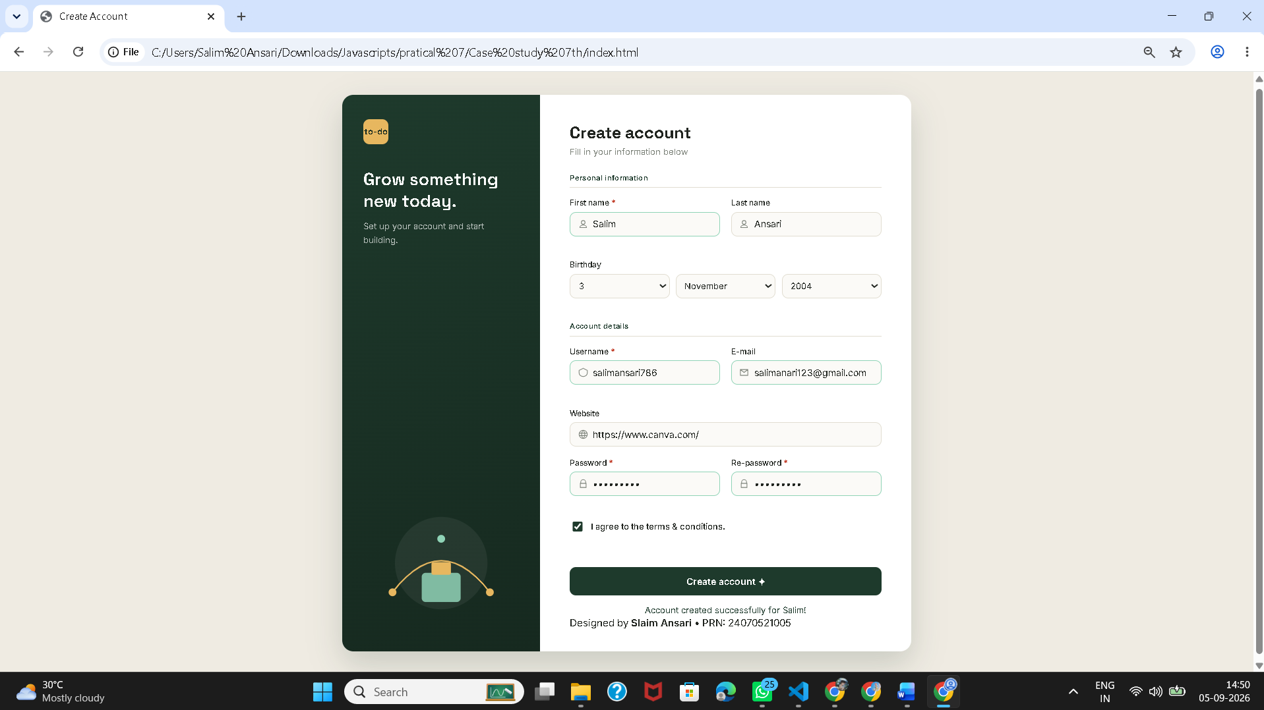

Conclusion –
The experiment was successfully performed to understand DOM traversal, manipulation, event handling, and form validation using JavaScript. A To-Do List application with Add, Edit, and Delete features was developed, and a registration form was implemented with dynamic validation and error handling.

